 | 10.1.11 Editors - Compositor Editor - Header - Add Menu - Mask
Table of content
Detailed table of content 1
Add menu - Matte 3
Cryptomatte 3
Cryptomatte (Legacy) 5
Box Mask 6
Ellipse Mask 8
Double Edge Mask 9
ID Mask 10

Detailed table of content
Detailed table of content
Detailed table of content 1
Add menu - Matte 3
Cryptomatte 3
Usage 4
Inputs 4
Image 4
Properties 4
Render / Image 4
Render 4
Scene Property 4
Cryptomatte Layer 4
Image 4
Image Property 4
Cryptomatte Layer 4
Matte ID 5
Outputs 5
Image 5
Matte 5
Pick 5
Cryptomatte (Legacy) 5
Usage 5
Adding/Removing Layers 6
Inputs 6
Image 6
Crypto Passes 6
Properties 6
Add/Remove 6
Matte ID 6
Outputs 6
Image 6
Matte 6
Pick 6
Box Mask 6
Inputs 6
Mask 6
Value 7
Properties 7
X, Y 7
Width 7
Height 7
Rotation 7
Mask Type 7
Add 7
Subtract 7
Not 7
Outputs 7
Mask 7
Ellipse Mask 8
Inputs 8
Mask 8
Value 8
Properties 8
X, Y 8
Width 8
Height 8
Rotation 8
Mask Type 8
Add 8
Subtract 8
Multiply 8
Not 9
Outputs 9
Mask 9
Double Edge Mask 9
Inputs 9
Inner Mask 9
Outer Mask 9
Properties 9
Inner Edge 9
All 9
Adjacent Only 9
Buffer Edge 9
Keep In 9
Bleed Out 10
Outputs 10
Mask 10
ID Mask 10
Inputs 10
ID value 10
Properties 10
Index 10
Anti-Aliased 10
Outputs 10
Alpha 10
Setup 10

Add menu - Matte
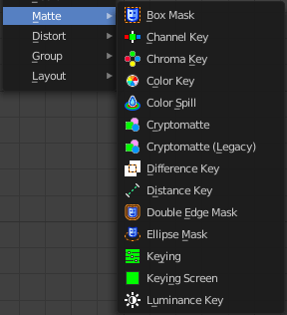
These nodes give you the essential tools for creating a Matte for images that do not already have their own Alpha Channel. One usage scenario is blue-screen or green-screen footage, where live action is shot in front of a blue or green backdrop for replacement by a matte painting or virtual background.
In general, hook up these nodes to a viewer, set your Image Editor to show the Viewer node, and play with the sliders in real-time using a sample image from the footage, to get the settings right. In some cases, small adjustments can eliminate artifacts or foreground image degradation. Taking out too much green can result in foreground actors looking flat or blueish/purplish.
You can and should chain these nodes together, improving your masking and color correction in successive refinements, using each node’s strengths to operate on the previous node’s output. Keying Node is the closest to a “does-it-all” node for green screens, but the best results stem from a combination of techniques.
Note!
Garbage Matte is not a node, but a technique selecting what to exclude from an image. It is a Mask used to identify content to be removed from an image that cannot be removed by an automatic process like chroma keying. It is used either to select specific content to be removed, or it is the inverse of a rough selection of the subject; removing everything else.
Some nodes accept a garbage matte directly. For those that don’t, you can still apply one by subtracting the garbage matte from the matte generated by the node.
Simple garbage mattes can be created with the Box Mask or the Ellipse Mask. More complicated matte shapes using a Double Edge Mask or using a Mask.

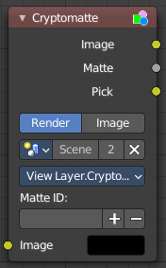
Cryptomatte
The Cryptomatte node uses the Cryptomatte standard to efficiently create mattes for compositing. Cycles outputs the required render passes, which can then be used in the Compositor or another Compositor with Cryptomatte support to create masks for specified objects.
Unlike the Material and Object Index passes, the objects to isolate are selected in compositing, and mattes will be anti-aliased and take into account effects like motion blur and transparency.

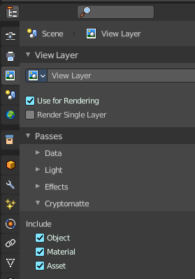
Usage
Enable Cryptomatte Object render pass in the Passes panel, and render.
In the compositing nodes, create a Cryptomatte node and link the Render Layer matching Image and Cryptomatte passes to it.
Attach a Viewer node to the Pick output of the Cryptomatte node.
Use the Cryptomatte Add/Remove button to sample objects in the Pick Viewer node.
Use the Matte output of the Cryptomatte node to get the alpha mask.

Inputs

Image
Standard image input.

Properties

Render / Image
Use the render result or an external image as the base image for cryptomatte.

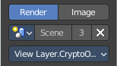
Render
Use Cryptomatte data that are stored as part of the render.

Scene Property
Pick the scene that you want to use.

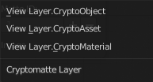
Cryptomatte Layer
Pick the cryptomatte layer that you want to use.

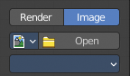
Image
Use Cryptomatte data that are stored inside a multilayered OpenEXR image.

Image Property
Pick the image that you want to use.

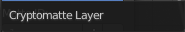
Cryptomatte Layer
Pick the cryptomatte layer that you want to use.

Matte ID
List of object and material crypto IDs to include in matte. This can be used for example to quickly clear all mattes by deleting the text or used to copy-and-paste crypto IDs from other software.

Outputs

Image
A colored output of the input image with the matte applied to only include selected layers.

Matte
A black-and-white alpha mask of the all the selected crypto layers.

Pick
A colored representation of the Cryptomatte pass which can be used with a Viewer node to select which crypto passes are used to create the matte image.

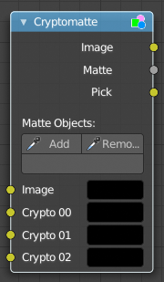
Cryptomatte (Legacy)
This is the legacy node version.
The Cryptomatte node uses the Cryptomatte standard to efficiently create mattes for compositing. Cycles outputs the required render passes, which can then be used in the Compositor or another Compositor with Cryptomatte support to create masks for specified objects.
Unlike the Material and Object Index passes, the objects to isolate are selected in compositing, and mattes will be anti-aliased and take into account effects like motion blur and transparency.

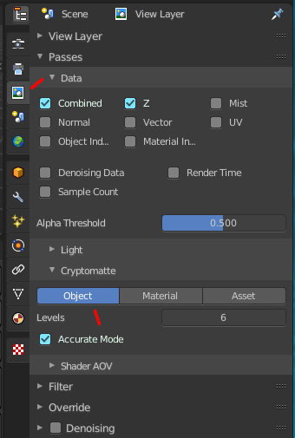
Usage
Enable Cryptomatte Object render pass in the Passes panel, and render.
In the compositing nodes, create a Cryptomatte node and link the Render Layer matching Image and Cryptomatte passes to it.
Attach a Viewer node to the Pick output of the Cryptomatte node.
Use the Cryptomatte Add/Remove button to sample objects in the Pick Viewer node.
Use the Matte output of the Cryptomatte node to get the alpha mask.

Adding/Removing Layers
By default there are only four crypto layers available as inputs to the Cryptomatte node. You can add or remove layer inputs through Sidebar > Item > Properties > Add/Remove Crypto Layer. These operators will add/remove layers from the bottom of the pass inputs.

Inputs

Image
Standard image input.

Crypto Passes
Each crypto layer will be given its own render pass; each of these render passes must be connected to one of these crypto layer inputs. By default there are only four layers, see Adding/Removing Layers to add more.

Properties

Add/Remove
Adds/Removes an object or material from matte, by picking a color from the Pick output.

Matte ID
List of object and material crypto IDs to include in matte. This can be used for example to quickly clear all mattes by deleting the text or used to copy-and-paste crypto IDs from other software.

Outputs

Image
A colored output of the input image with the matte applied to only include selected layers.

Matte
A black-and-white alpha mask of the all the selected crypto layers.

Pick
A colored representation of the Cryptomatte pass which can be used with a Viewer node to select which crypto passes are used to create the matte image.

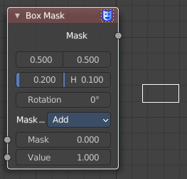
Box Mask
The Box Mask node creates an image suitable for use as a simple matte.

Inputs

Mask
An optional mask to use as the base for mask operations.

Value
Intensity of the generated mask.

Properties

X, Y
Position of the center of the box as a fraction of the total width or height. (0.5, 0.5 creates a centered box; 0.0, 0.0 creates a box in the lower left.)

Width
Width of the box as a fraction of the total image width.

Height
Height of the box as a fraction of the total image width, not height.

Rotation
Rotation of the box around its center point.

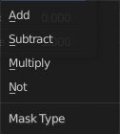
Mask Type
Operation to use against the input mask.

Add
This yields the union of the input mask and the generated mask: Areas covered by the generated mask are set to the specified Value. Other parts of the input masked are passed through unchanged, or set to black if there is no input mask.

Subtract
Values of the input mask have the specified Value subtracted from them.
Multiply
This yields the intersection of this generated mask and the input mask: Values of the input mask are multiplied by the specified Value for the area covered by the generated mask. All other areas become black.

Not
Any area covered by both the input mask and the generated mask becomes black. Areas covered by the generated mask that are black on the input mask become the specified Value. Areas uncovered by the generated mask remain unchanged.

Outputs

Mask
A generated rectangular mask merged with the input mask. The created mask is the size of the current scene render dimensions.
Tip. For soft edges, pass the output mask through a slight Blur node.

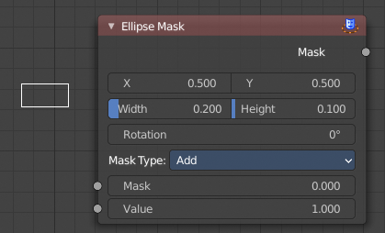
Ellipse Mask
The Ellipse Mask node creates an image suitable for use as a simple matte or vignette mask.

Inputs

Mask
An optional mask to use as the base for mask operations.

Value
Intensity of the generated mask.

Properties

X, Y
Position of the center of the ellipse as a fraction of the total width or height. (0.5, 0.5 creates a centered ellipse; 0.0, 0.0 creates an ellipse with its center in the lower left.)

Width
Width of the ellipse as a fraction of the total image width.

Height
Height of the ellipse as a fraction of the total image width, not height. Equal Width and Height values with produce a circle.

Rotation
Rotation of the ellipse around its center point.

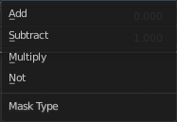
Mask Type
What operation to use against the input mask.

Add
This yields the union of the input mask and the generated mask: Areas covered by the generated mask are set to the specified Value. Other parts of the input masked are passed through unchanged, or set to black if there is no input mask.

Subtract
Values of the input mask have the specified Value subtracted from them.

Multiply
This yields the intersection of this generated mask and the input mask: Values of the input mask are multiplied by the specified Value for the area covered by the generated mask. All other areas become black.

Not
Any area covered by both the input mask and the generated mask becomes black. Areas covered by the generated mask that are black on the input mask become the specified Value. Areas uncovered by the generated mask remain unchanged.

Outputs

Mask
A generated elliptical mask merged with the input mask. The created mask is the size of the current scene render dimensions.
Tip. For soft edges, pass the output mask through a slight Blur node. For a vignette, pass the output of this through a heavy blur.

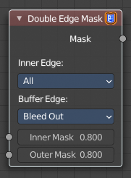
Double Edge Mask
The Double Edge Mask node creates a gradient between two masks.

Inputs

Inner Mask
A mask representing the inside shape, which will be fully white.

Outer Mask
A mask representing the outside shape, which will fade from black at its edges to white at the Inner Mask.

Properties

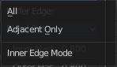
Inner Edge

All
All shapes in the Inner Mask contribute to the gradient, even ones that do not touch the Outer Mask shape.

Adjacent Only
Only shapes in the Inner Mask that overlap with the Outer Mask contribute to the gradient.

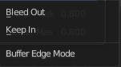
Buffer Edge

Keep In
Parts of the Outer Mask that touch the edge of the image are treated as if they stop at the edge.

Bleed Out
Parts of the Outer Mask that touch the edge of the image are extended beyond the boundary of the image.

Outputs

Mask
Standard mask output.

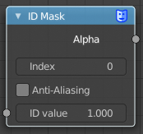
ID Mask
The ID Mask Node can be used to access an alpha mask per object or per material.

Inputs

ID value
Input for the Object Index or Material Index render pass. Which is an output of the Render Layers node or the Image node with a multi-layer format.

Properties

Index
Selection of the previously specified index.

Anti-Aliased
This post-process function refines the mask. See anti-aliasing.

Outputs

Alpha
The mask is white where the object is and black where it is not. If the object is transparent, the alpha mask represent that with gray values.

Setup
An index can be specify for any object or Cycles material in the scene. The Object Index can be set in the Relations panel in the Object tab in the Properties Editor. And for Cycles in the Settings Panel in the Material tab in the Properties editor. To be accessible after rendering, Object Index or Material Index render pass has to be enabled in the Passes panel in the View Layer properties tab in the Properties editor.
